RECIPE  
Strawberry Pie (2 Pies)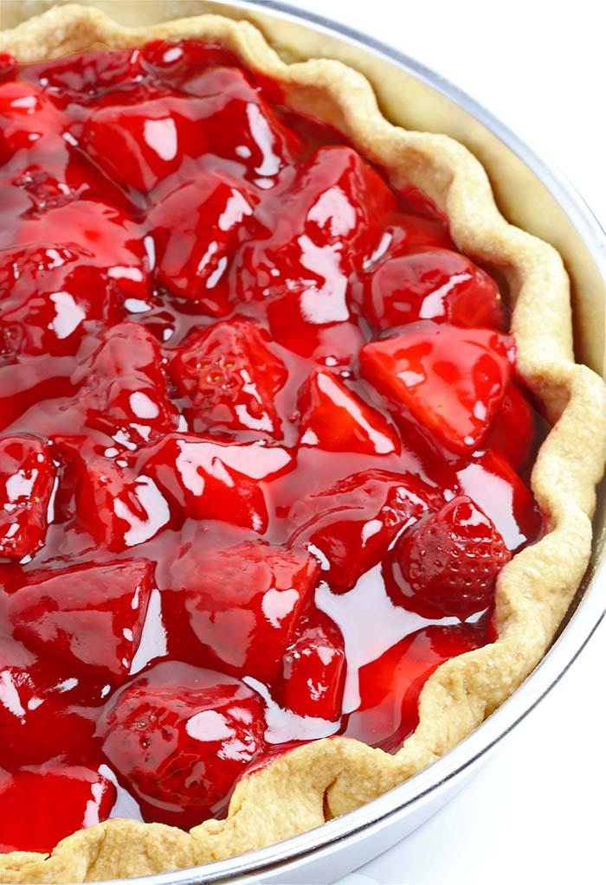

# Ingredients

* 1 ½ cup sugar
* 2 cups water
* 2 ½ tbsp cornstarch
* 3 oz box strawberry jello
* Two baked pie shells
* 1 quart cleaned and halved strawberries

# Preparation

1. Prepare and bake pie shells
2. Boil sugar water and cornstarch until clear
3. Add jello
4. Take off burner and cool
5. As the jello cools, arrange the strawberries in the cool pie shells
6. Pour spoonfuls of jello mixture into the pie shells, ensuring that every strawberry is covered
7. Refrigerate until cool and jello has set